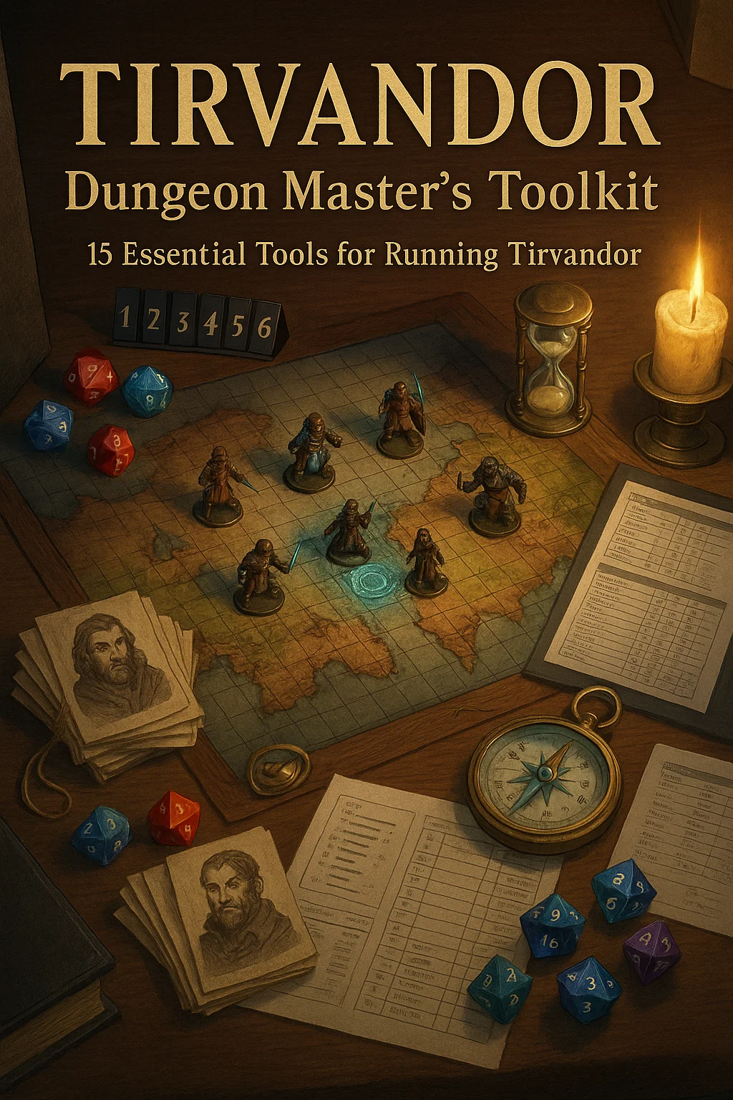

© 2024-2025 Tirvandor Campaign Setting. All rights reserved.
For personal tabletop use only. Not for commercial distribution.

Random Encounter Tables
For Improvisation & Dynamic Gameplay

RANDOM ENCOUNTER TABLES

For Improvisation & Dynamic Gameplay
Use these tables when:
- Players go off-script
- You need to fill travel time
- Random events add excitement
- Campaign needs unpredictability

How To Use These Tables
Rolling Encounters:
- d20 for most tables (quick and easy)
- d100 for maximum variety (combine two d10s)
- Frequency: Roll once per day of travel or every 4 hours in dangerous areas
Encounter Difficulty:
- Easy (1-7): Roleplay opportunity or minor obstacle
- Medium (8-14): Requires some effort or resources
- Hard (15-18): Significant challenge
- Deadly (19-20): Major threat, possibly retreat

Urban Encounters

Kaer Thandros (Capital City - Thaldros)
d20 Roll | Encounter
1 | Street performer juggling flaming swords attracts crowd
2 | Pickpocket (Rogue 2) attempts to steal from party member (DC 15 Perception)
3 | City watch patrol (4 guards) stops party for routine questioning
4 | Merchant's wagon breaks down, needs help, offers 5 gp reward
5 | Noble's procession blocks street, arrogant guards demand respect
6 | Two drunks brawling outside tavern, escalating violence
7 | Lost child crying for parents, reuniting earns blessing from grateful mother
8 | Beggar with crucial information about quest (if treated kindly)
9 | Street preacher warns of coming doom, may have legitimate visions
10 | Food vendor's cart catches fire, chaos ensues
11 | Rival adventuring party passes by, potential friends or enemies
12 | Secret message delivered to wrong person (party member), pursuers incoming
13 | Public execution being prepared, criminal claims innocence
14 | Merchant selling "magical" items (50% fake, DC 15 Arcana to detect)
15 | Street gang (6 thugs) demands "toll" to pass through their territory
16 | Nobleman's carriage nearly runs over pedestrian, guards threaten witnesses
17 | Underground fight club scout recruiting "fresh meat" for arena
18 | Assassin (Rogue 6) stalking someone else, party witnesses attempt
19 | Cult member distributing pamphlets, recruiting for ritual tonight
20 | City watch captain personally seeking adventurers for urgent quest

Goldreach (Merchant Hub)
d20 Roll | Encounter
1 | Auction for exotic goods, players can bid on rare items
2 | Two merchants arguing loudly over contract dispute
3 | Market inspector accuses vendor of selling spoiled goods
4 | Street magician entertaining crowd with genuine cantrips
5 | Merchant League recruiter offers lucrative but risky job
6 | Spice vendor's samples attract hungry crowd, free samples!
7 | Rumors spreading about ship carrying incredible treasure
8 | Conman selling "treasure map" (DC 18 Insight to detect lie)
9 | Warehouse fire, need help saving goods for reward
10 | Foreign diplomat's entourage seeking guides/translators
11 | Black market contact signals party with coded message
12 | Tax collector with guards demanding "special fees"
13 | Rival merchant hires party to investigate competition
14 | Street urchin knows secret passage to restricted area
15 | Merchant prince's bodyguards testing security, aggressive
16 | Syndicate operative conducting "business" in alley, notices party
17 | Cargo ship attacked by pirates in harbor, crew needs rescue
18 | Merchant caravandisappears, merchant offers reward for investigation
19 | Warehouse contains illegal goods, guards won't let anyone near
20 | Assassination attempt on merchant prince in crowded market

Aethermere (Elven Capital)
d20 Roll | Encounter
1 | Elven children practicing magic under mentor's supervision
2 | Street artist painting beautiful murals with magical paints
3 | Philosophical debate between scholars attracts listeners
4 | Meditation circle in park, newcomers welcome to join
5 | Lost magical familiar seeking wizard owner
6 | Elven guard politely asks about party's business in city
7 | Stargazer offering to read fortunes, surprisingly accurate
8 | Ancient elf shares story of historical event party is investigating
9 | Magical fountain malfunction creates minor water elementals (harmless)
10 | Music performance in square, hauntingly beautiful
11 | Wizard's experiment goes wrong, minor magical mishap
12 | Council messenger seeks party for diplomatic mission
13 | Elven noble challenges party member to arcane duel (non-lethal)
14 | Secret society recruiter approaches promising "true knowledge"
15 | Magical beast escaped from academy, need help recapturing
16 | Political protest against High Queen's policies (peaceful but tense)
17 | Shadow creature spotted in alley, investigations reveal spy network
18 | Planar rift briefly opens, glimpse of Feywild, attracts attention
19 | Assassination attempt on council member in public
20 | Archmage's tower experiment causes magical anomaly affecting whole district

Wilderness Encounters

Forests & Woodlands
d20 Roll | Encounter | CR
1 | Deer herd crossing path, peaceful | -
2 | Abandoned campsite with fresh supplies | -
3 | Friendly ranger offers trail advice | -
4 | Berry bushes (edible, DC 12 Nature to identify) | -
5 | Lost traveler seeks directions to nearest settlement | -
6 | Ancient tree with carved warnings in old language | -
7 | Trapped animal (fox/rabbit) can be freed | -
8 | Owlbear tracks, creature nearby (can avoid) | 3
9 | Bandit scouts (3 scouts) watching road | 1
10 | Treant observing intruders, willing to talk if respectful | 9
11 | Poisonous plants block path (DC 15 Nature to navigate) | -
12 | Hidden druid circle, suspicious druids question party | -
13 | Giant spiders in web-covered grove | 1-3
14 | Fey creature offering bargain (trickster) | Varies
15 | Wolves (pack of 6) hunting nearby | 2
16 | Goblin war band (8 goblins + 1 goblin boss) | 2
17 | Wounded unicorn being hunted by evil rangers | 5
18 | Shambling mound guarding ancient grove | 5
19 | Green dragon wyrmling claiming territory | 2
20 | Awakened trees attack loggers, need mediation or fight | 7

Mountains & Hills
d20 Roll | Encounter | CR
1 | Mountain goats on cliff face, impressive view | -
2 | Old mine entrance, possibly abandoned or occupied | -
3 | Hermit living in cave, knows region secrets | -
4 | Eagle's nest with shiny objects (possible treasure) | -
5 | Avalanche danger (DC 15 Survival to detect early) | -
6 | Dwarven merchant caravan seeks guards | -
7 | Rock slide blocks path, need to clear or find alternate route | -
8 | Mountain lion stalking prey | 1
9 | Orc scouts (4 orcs) on patrol | 2
10 | Griffon nesting on peak, territorial | 2
11 | Frost giant hunter tracking party | 8
12 | Abandoned dwarven outpost, possibly haunted | -
13 | Roc flying overhead, casts massive shadow | 11
14 | Stone giant sitting, philosophizing, surprisingly friendly | 7
15 | Landslide trap set by bandits | -
16 | Wyvern hunting from cliff | 6
17 | Hill giant with pet dire wolves | 5
18 | Mountain pass controlled by toll-demanding ogres (3) | 3
19 | Young red dragon's lair, dragon present | 10
20 | Ancient mountain fortress, occupied by hobgoblin warband | 5+

Desert (Sundara Region)
d20 Roll | Encounter | CR
1 | Oasis with travelers resting, friendly | -
2 | Mirage of palace/treasure (illusion) | -
3 | Desert nomads offer trade and information | -
4 | Ancient ruins partially buried in sand | -
5 | Sandstorm approaching (DC 12 Survival for shelter) | -
6 | Camel caravan heading same direction | -
7 | Heat exhaustion check (DC 12 CON or 1 level exhaustion) | -
8 | Giant scorpions (2) hunting | 3
9 | Sand bandits (6 bandits on camels) demand goods | 2
10 | Blue dragon wyrmling hunting | 3
11 | Efreet offering dubious bargain | 11
12 | Lamia disguised as traveler, seeking to charm victims | 4
13 | Mummy lord's tomb entrance uncovered by wind | 15
14 | Yuan-ti infiltrator posing as merchant | 3
15 | Dust devils (4 dust mephits) from elemental disturbance | 2
16 | Giant sandworm burrows beneath party | 8
17 | Sphinx guarding ancient secret, riddle challenge | 11
18 | Desert cultists performing ritual to summon fire elemental | 5
19 | Adult blue dragon making lair in ruins | 16
20 | Dao (earth genie) slave traders hunting for victims | 11

Road Encounters (Main Highways)
d20 Roll | Encounter
1 | Merchant wagon with friendly trader
2 | Traveling bard offers to join party for safety
3 | Pilgrims heading to temple, share food
4 | Road maintenance crew working
5 | Broken wagon needs assistance
6 | Military patrol passes, asks about safety ahead
7 | Traveling circus heading to next town
8 | Message runner seeks escort for dangerous stretch
9 | Bandit ambush (6 bandits) using fallen tree
10 | Merchant caravan under attack, needs rescue
11 | Toll bridge with excessive fees
12 | Highwayman (Rogue 5) demands valuables
13 | Fake merchants (actually disguised bandits)
14 | Necromancer's undead (4 zombies, 2 skeletons) wandering
15 | Rogue construct (animated armor) malfunctioning
16 | Fleeing refugees warn of monster ahead
17 | Troll demands toll at bridge
18 | Knights hunting dangerous criminal, ask if party has seen them
19 | Vampire spawn hunting travelers at night
20 | Dragon flying overhead, considers party interesting

Dungeon Encounters
d20 Roll | Encounter | CR
1 | Empty room with graffiti from previous adventurers | -
2 | Harmless dungeon ecology (bats, rats, moss) | -
3 | Trapped chest (DC 15 to detect/disarm) | -
4 | Skeleton remains of previous adventurer, maybe items | -
5 | Wandering monster: 4 giant rats | 1/4 each
6 | Tripwire alarm (alerts dungeon inhabitants) | -
7 | Pit trap (10ft deep, DC 15 Perception) | -
8 | Gelatinous cube slowly moving through corridor | 2
9 | Ochre jelly dropping from ceiling | 2
10 | Rust monster attracted to metal equipment | 1/2
11 | Gargoyles (2) posing as statues | 2 each
12 | Mimic disguised as treasure chest | 2
13 | Patrol: 6 goblins checking rooms | 1/4 each
14 | Ghost of murdered adventurer, may help if freed | 4
15 | Flaming sphere trap (DC 15 DEX save) | -
16 | Spectator guarding important chamber | 3
17 | Grick (2) hunting from ceiling crevices | 2 each
18 | Black pudding in dark corner | 4
19 | Mind flayer interrogating prisoner | 7
20 | Beholder observing via scrying sensor | Varies

Social Encounters (Taverns & Markets)
d20 Roll | Encounter
1 | Locals sharing harmless gossip and rumors
2 | Card game in progress, players welcome to join
3 | Drunk patron tells exaggerated adventure stories
4 | Bard performing, takes requests
5 | Two patrons arguing about politics
6 | Job board has several quests posted
7 | Information broker subtly offers services
8 | Local noble slumming incognito
9 | Merchant seeking bodyguards for dangerous delivery
10 | Gambling den in back room (risk/reward)
11 | Mysterious stranger buys party a round, asks cryptic questions
12 | Bar fight breaks out (4 thugs vs 4 guards)
13 | Assassin sizing up target, party may intervene
14 | Spy exchanging information via dead drop
15 | Syndicate members conducting "business meeting"
16 | Wanted criminal hiding among patrons
17 | Cultist recruiting members with promises of power
18 | Drunk reveals significant plot information accidentally
19 | Armed raid by city watch looking for fugitive
20 | Demon cultist about to activate hidden summoning circle

Naval/Coastal Encounters
d20 Roll | Encounter | CR
1 | Dolphins swimming alongside ship (good omen) | -
2 | Flying fish leap onto deck | -
3 | Passing merchant ship, friendly waves | -
4 | Floating wreckage from recent battle | -
5 | Seabirds circling (land nearby or feeding frenzy) | -
6 | Storm clouds gathering (DC 12 Survival to navigate) | -
7 | Sahuagin scouts observing from distance | 1/2 each
8 | Giant shark circling ship | 5
9 | Pirate ship on horizon (chase or flight?) | Varies
10 | Reef visible beneath water, navigation hazard | -
11 | Merfolk seeking trade or assistance | -
12 | Sea hags disguised as drowning victims | 2 each
13 | Water elemental disturbed by ship passage | 5
14 | Kraken tentacle surfaces briefly (ominous) | -
15 | Mutiny attempt on ship (crew divided) | Varies
16 | Ghost ship drifting past, possibly boardable | -
17 | Hydra living in cove, attacks ships | 8
18 | Sahuagin war party (10 warriors) attacking | 1/2 each
19 | Young bronze dragon seeking conversation | 8
20 | Adult dragon turtle surfacing near ship | 17

Random NPC Generator
Use this when party talks to someone you didn't prepare!

Name (d20)
d20 | Race
1-5 | Human (roll human names)
6-10 | Dwarf (roll dwarf names)
11-15 | Elf (roll elf names)
16-18 | Halfling
19 | Half-Orc
20 | Tiefling

Occupation (d20)
d20 | Occupation
1 | Guard
2 | Farmer
3 | Blacksmith
4 | Merchant
5 | Innkeeper
6 | Scholar
7 | Priest
8 | Miner
9 | Fisher
10 | Baker
11 | Carpenter
12 | Tailor
13 | Leatherworker
14 | Hunter
15 | Healer
16 | Scribe
17 | Performer
18 | Sailor
19 | Criminal
20 | Noble

Personality Quirk (d20)
d20 | Quirk
1 | Talks very loudly
2 | Whispers constantly
3 | Laughs at own jokes
4 | Very suspicious
5 | Overly friendly
6 | Nervous fidgeting
7 | Uses big words incorrectly
8 | Speaks in rhyme
9 | Has tic/twitch
10 | Forgetful
11 | Obsessed with cleanliness
12 | Smells bad
13 | Collects weird things
14 | Superstitious
15 | Chronic liar
16 | Brutally honest
17 | Extremely polite
18 | Constantly eating
19 | Refers to self in third person
20 | Has imaginary friend

Secret (d12)
d12 | Secret
1 | Owes money to loan shark
2 | Witnessed a crime
3 | Is having an affair
4 | Secretly wealthy
5 | Wanted in another city
6 | Actually a spy
7 | Knows hidden treasure location
8 | Related to someone famous
9 | Cursed by witch
10 | Member of secret society
11 | Is being blackmailed
12 | Knows major plot information

Plot Hooks (d20)
Roll when you need an adventure seed on the fly:
d20 | Plot Hook
1 | The Vanishing: People disappearing from specific location, pattern emerging
2 | The Theft: Valuable item stolen, multiple factions want it back
3 | The Murder: High-profile killing, evidence points to innocent person
4 | The Plague: Mysterious illness spreading, unusual symptoms
5 | The Haunting: Undead/spirits emerging from old battleground
6 | The Ritual: Cultists gathering for ceremony, must be stopped
7 | The Blackmail: NPC being blackmailed, needs evidence destroyed
8 | The Artifact: Ancient item discovered, everyone wants it
9 | The Prophecy: Old prediction coming true, interpretation disputed
10 | The Invasion: Monster/army gathering nearby, imminent attack
11 | The Betrayal: Trusted ally revealed as traitor/spy
12 | The Curse: Ancient curse affecting location/family
13 | The Discovery: New location/dungeon uncovered
14 | The Rescue: Important person kidnapped, ransom demanded
15 | The Competition: Rival group seeking same goal
16 | The Natural Disaster: Earthquake/flood/eruption threatening settlement
17 | The Political: Alliance forming/breaking, sides must be chosen
18 | The Investigation: Crime spree with pattern, catch culprit
19 | The Lost Heir: True heir revealed, succession crisis
20 | The Planar: Barrier weakening, otherworldly incursion

Dm Tips For Using These Tables
Modifying Difficulty:
- Lower CR encounters by reducing number of enemies
- Increase difficulty by adding environmental hazards
- Adjust tactics based on party strength
Making Encounters Memorable:
- Add unique twist to standard encounter
- Give named NPCs personality quirks
- Connect random encounters to main plot occasionally
When NOT to Roll:
- Party just finished major encounter
- Story pacing requires uninterrupted travel
- Scene is already dramatic enough
Encounter Frequency:
- Safe Roads: 10% chance per day
- Wilderness: 25% chance per day
- Dangerous Areas: 50% chance per 4 hours
- Dungeons: 1 encounter per 30 minutes exploring
These tables give you infinite improvisation fuel!

